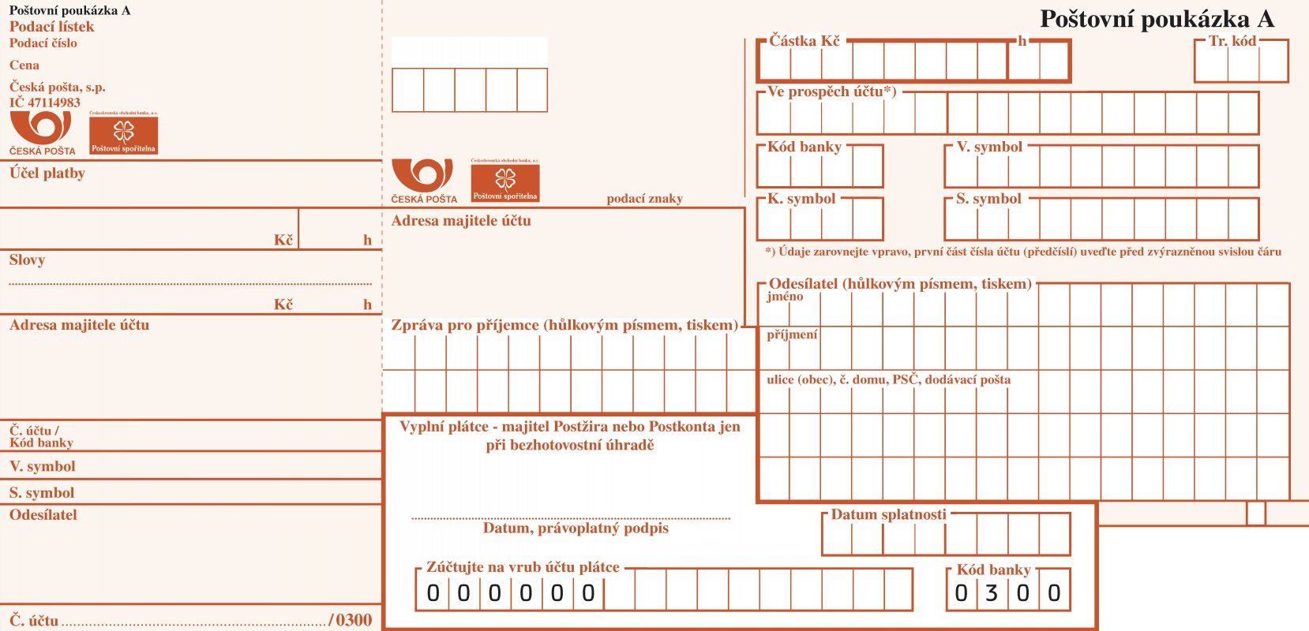

[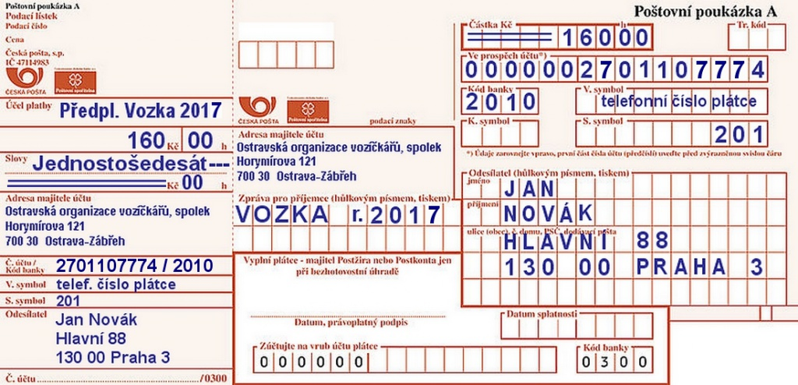](https://www.google.cz/url?sa=i&url=https://www.vozka.org/odkazy-v-hlavicce/prihlaska-k-odberu/&psig=AOvVaw0QiTjSxBwxcsxwF_K7is1d&ust=1592830581126000&source=images&cd=vfe&ved=0CAIQjRxqFwoTCPiEv736kuoCFQAAAAAdAAAAABAx)