CLOTHES - OBLEČENÍ

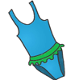
bathing suit - plavky
/'beɪðɪŋ sju:t/
a piece of clothing worn by people when they go swimming

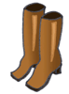
boots - boty (zimní, vysoké)
/'bu:ts/
high shoes

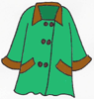
coat - kabát
/'kəʊt/
a piece of clothing that you wear over your other clothes, usually in winter

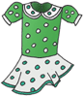
dress - šaty
/'dres/
a piece of women's clothing, it is usually long

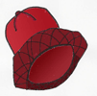

hat - klobouk, čepice
/'hæt/
a piece of clothing that covers your head

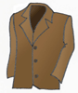
jacket - sako, bunda
/'dʒækɪt/
a short coat, usually lighter and not as warm as a chat

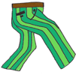
pants - kalhoty
/'pænts/
a piece of clothing that covers the legs

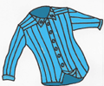
shirt - košile
/'šɜ:t/
a piece of clothing with long sleeves and buttons at the front
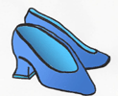
shoes - boty
/'šu:z/
- the things that you wear on your feet, they are usually made of plastic or leader

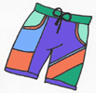
shorts - kraťasy, šortky, trenky
/'šɔ:ts/
a kind of short trousers

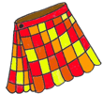
skirt - sukně
/'skɜ:t/
noun - a piece of women's clothing that covers their legs to the knees or Langer

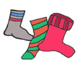
socks - ponožky
/'sɒks/
pieces of clothing that you wear on your feet

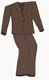
suit - oblek
/'su:t/
formal clothes worn by men, consisting of trousers, shirt, tie and a jacket

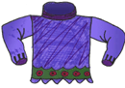
sweater - svetr, mikina
/'swetə/
a piece of clothing with long sleeves, it is usually warm and made of wool, people wear it on their T-shirt or shirt, under the chat

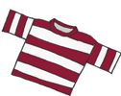
T-shirt - tričko
BrE
/'ti:ʃɜ:t/
a piece of clothing with short sleeves, usually made of cotton

