DAILY ROUTINES

In the morning…….

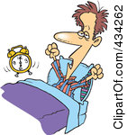  

I_____up at_____o’clock. I_______breakfast. I __________school at_____

In the afternoon…….

  

I______lunch at______ I_____my homework at_____ I ______computer at____

In the evening……

[](http://www.sodahead.com/entertainment/whos-your-favorite-madagascar-character/question-1295185/)  

I ______my friends at I_______TV at_______ I _____dinner at_______

 I _____to ______ at _________